**Focus keyword**: **SMS Sleep Disorder**

**Meta Title:**– **SMS Sleep Disorder** |vigoursoul

**Meta Description:** SMS Sleep Disorder is a rare sleep disorder in which people experience rapid eye movements (REM) during sleep that can cause them to act out their dreams.

**Feature Image:**

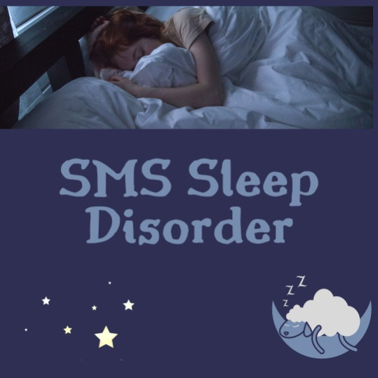

**SMS Sleep Disorder**

**SMS Sleep Disorder** is a medical condition in which a person experiences difficulty sleeping. This can include difficulty falling asleep, staying asleep, or getting enough quality sleep. Sleep disorders can be caused by physical or psychological issues, or a combination of both. Treatment for sleep disorders typically involves lifestyle changes, such as improving sleep hygiene, and in some cases, medications or other treatments.

**Basic Sleep Disorder:**

A somnipathy, often known as a sleep disorder, affects a person's sleep habits. Some sleep disorders are severe enough to affect how well people operate physically, mentally, socially, and emotionally. Actigraphy and polysomnography are two widely requested tests for identifying sleep problems.

The main categories of sleep disorders are dyssomnias, parasomnias, circadian rhythm sleep disorders, which affect the time of sleep, and other disorders, such as those brought on by physical or mental illnesses. Insomnia, the most prevalent sleep condition, is when a person has difficulty falling asleep, staying asleep, or getting up in the morning without a clear reason.  Additional sleep disorders include apnea, narcolepsy, hypersomnia (extreme drowsiness at inappropriate times), sleeping sickness (disruption of the sleep cycle owing to infection), sleepwalking, and night terrors.

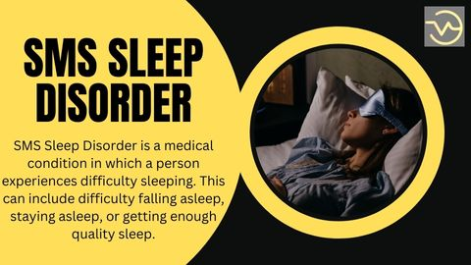

Night terrors and bruxism are just two of the conditions that might keep you up at night. The underlying illnesses should be the main focus of treatment for sleep difficulties that are a complication of mental, physical, or substance use disorders.

Both children and adults frequently experience primary sleep problems. However, because the majority of cases of sleep disturbances in children go undiagnosed, there is a serious lack of awareness. Increased drug use, age-related changes in circadian rhythms, environmental changes, lifestyle changes, previously diagnosed physiological issues, or stress are a few typical causes of the start of a sleep disturbance. The likelihood of acquiring sleep apnea, periodic limb movements, restless legs syndrome, REM sleep behavior disorders, insomnia, and irregular circadian rhythms is particularly elevated in the elderly.

**What is SMS Sleep Disorder?**

A complex, rare genetic disorder known as Smith-Magenis Syndrome **SMS Sleep Disorder** is characterized by a variety of congenital abnormalities and behavioral issues, including irregular sleeping habits. The individual and those providing care for them may be greatly impacted by SMS's frequent night awakenings and daytime lethargy.

A loss on chromosome 17's portion is what causes **SMS Sleep Disorder** the majority of the time. As a result, people with SMS may experience disruptions in their circadian rhythm, which controls a number of physiological processes, including sleep. The hormone melatonin is typically higher during the daytime rather than the night, which leads to the nightly sleep disturbance in **SMS Sleep Disorder**. Many people with **SMS Sleep Disorder** have inverted melatonin secretion.

It is possible that other factors, such as environment and routine, also significantly affect sleep for those with **SMS Sleep Disorder** as not all those with **SMS Sleep Disorder** who have sleep disturbance also exhibit this inverted melatonin production. SMS is a hereditary condition, but it is rarely passed from parent to child; instead, the majority of cases are the result of a spontaneous genetic change that takes place for reasons that are unknown. Unfortunately, misdiagnosis is frequently experienced because SMS is a highly variable disorder and shares similarities with other genetic conditions.

**SMS Sleep Disorder Symptoms**

Some of the most common symptoms of Smith-Magenis Syndrome **SMS Sleep Disorder** are difficulty falling asleep, frequent night awakenings, daytime lethargy, and inverted melatonin secretion. Other symptoms may include restlessness, nightmares, sleepwalking, snoring, and sleep apnea.

If you or someone you know is exhibiting any of these symptoms, it is important to seek help from a qualified medical professional. In addition to lifestyle changes, such as improving sleep hygiene, medications or other treatments may be necessary to manage **SMS Sleep Disorder.**

Smith-Magenis syndrome **SMS Sleep Disorder** is characterized by a wide range of behavioral problems, skeletal abnormalities, and/or sleep disturbances. These symptoms may not all be present in SMS patients because every case is different.

The signs and symptoms of **SMS Sleep Disorder** are listed below. SMS patients' sleep issues may evolve over time.

* Having trouble falling asleep
* Having trouble remaining asleep
* Reduced sleep duration being unable to enter REM sleep and frequently waking up at night (especially early in the morning)
* Regular drowsiness during the day
* Symptoms that stand out as characteristic
* Detailed medical and family background
* Comprehensive clinical assessment
* Genetic analyses

When a 17p11.2 deletion or RAI1 gene mutation is found, SMS diagnosis is confirmed. Polysomnography is a method that can be used to measure sleep disruptions brought on by SMS. An approach to capturing a person's physiological processes while they sleep is polysomnography.

Recordings are made of the heart rate, blood oxygen levels, respiration, eye and leg movements, and brain waves. To ascertain whether an inverted melatonin secretion is causing the person's sleep disturbance, melatonin analysis can also be carried out using blood samples.

**SMS Sleep Disorder Smith**

Magenis Syndrome (SMS) Sleep Disorder is a condition in which a person experiences difficulty sleeping. This can include difficulty falling asleep, staying asleep, or getting enough quality sleep. **SMS Sleep Disorder** is caused by a combination of physical and psychological factors, such as stress, poor sleep hygiene, or underlying medical conditions. Treatment **SMS Sleep Disorder** typically involves lifestyle changes, such as improving sleep hygiene, and in some cases, medications or other treatments.

If you are experiencing sleep disturbances, you should consult with a doctor to determine the underlying cause and develop a treatment plan. Your doctor may recommend lifestyle changes, such as improving your sleep hygiene, and may also consider the use of medications or other treatments. If you feel that your sleep disorder is impacting your life, it is important to seek help from a qualified medical professional.

**SMS Sleep Disorder Facial Features**

Smith-Magenis Syndrome (SMS) is a rare genetic disorder that is characterized by a range of physical and behavioral features. Some of the physical features associated with **SMS Sleep Disorder** include a round face, widely spaced eyes, low-set ears, a short nose, and a wide mouth.

People with **SMS Sleep Disorder** may also experience hearing and vision problems, as well as cognitive and developmental delays. Along with these physical features, **SMS Sleep Disorder** is also associated with sleep disturbances, such as difficulty falling asleep, frequent night awakenings, and daytime lethargy. If you or someone you know has SMS, it is important to seek help from a qualified medical professional to determine the best course of treatment.

A developmental condition known as Smith-Magenis syndrome affects various body systems. The main characteristics of this illness are mild to moderate intellectual disability, delayed speech and language skills, distinctive facial features, sleep disturbances, and behavioral issues.

Smith-Magenis syndrome is characterized by irregular sleep patterns, which typically start in early childhood. People who are affected may sleep a lot during the day, but they have trouble falling asleep at night and frequently wake up in the middle of the night or early the next morning.

Although most Smith-Magenis syndrome sufferers also struggle with behavioral issues, they typically have warm, likeable personalities. These include aggressive behavior, frequent tantrums and outbursts, anxiety, impulsivity, and trouble focusing. Self-harm, such as biting, hitting, head banging, and skin picking, is extremely prevalent. A behavioral trait is the habitual hugging of oneself.

**Therapies for sleeping problems**

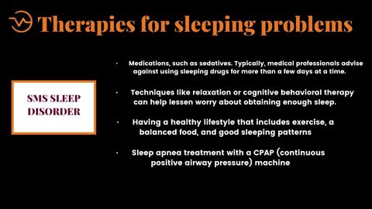

Depending on the type of sleep disturbance you have, there are several treatments. They may consist of:

* Having a healthy lifestyle that includes exercise, a balanced food, and good sleeping patterns
* Techniques like relaxation or cognitive behavioral therapy can help lessen worry about obtaining enough sleep.
* Sleep apnea treatment with a CPAP (continuous positive airway pressure) machine
* dazzling light therapy (in the morning)
* Medications, such as sedatives. Typically, medical professionals advise against using sleeping drugs for more than a few days at a time.
* Items that are natural, like melatonin. These items are typically for short-term usage but may be helpful to some persons. Before taking any of them, make sure to speak with your doctor.

**SMS Sleep Disorder- FAQS**

**What is Smith-Magenis Syndrome (SMS) Sleep Disorder?**

Smith-Magenis Syndrome **SMS Sleep Disorder** is a condition in which a person experiences difficulty sleeping. This can include difficulty falling asleep, staying asleep, or getting enough quality sleep. SMS sleep disorder is caused by a combination of physical and psychological factors, such as stress, poor sleep hygiene, or underlying medical conditions.

**What are the symptoms of SMS Sleep Disorder?**

The symptoms of **SMS Sleep Disorder** include difficulty falling asleep, frequent night awakenings, daytime lethargy, restlessness, nightmares, sleepwalking, snoring, and sleep apnea.

**What are the causes of SMS Sleep Disorder?**

The cause of **SMS Sleep Disorder** is typically a combination of physical and psychological factors, such as stress, poor sleep hygiene, or underlying medical conditions.

**How is SMS Sleep Disorder diagnosed?**

**SMS Sleep Disorder** is typically diagnosed through a combination of symptoms that stand out as characteristic, a detailed medical and family background, a comprehensive clinical assessment, and genetic analyses.

**How is SMS Sleep Disorder treated?**

Treatment for **SMS Sleep Disorder** typically involves lifestyle changes, such as improving sleep hygiene, and in some cases, medications or other treatments. It is important to consult with a doctor to determine the underlying cause and develop a treatment plan.

**Are there any long-term effects of SMS Sleep Disorder?**

The long-term effects of **SMS Sleep Disorder** can vary depending on the severity of the disorder. It is important to seek help from a qualified medical professional if you feel that your sleep disorder is impacting your life.

**Conclusion**

Smith-Magenis Syndrome **SMS Sleep Disorder** is a condition in which a person experiences difficulty sleeping. This can include difficulty falling asleep, staying asleep, or getting enough quality sleep. SMS sleep disorder is caused by a combination of physical and psychological factors, such as stress, poor sleep hygiene, or underlying medical conditions.

Treatment for **SMS Sleep Disorder** typically involves lifestyle changes, such as improving sleep hygiene, and in some cases, medications or other treatments. If you are experiencing sleep disturbances, it is important to seek help from a qualified medical professional to determine the underlying cause and develop a treatment plan.